ROCKET Classification System

Assessment of Capitellar OCD on MRI

MRI Sequence Protocol:
- Axial FSE (TSE) T2 with fat saturation
- Coronal T1
- Coronal FSE (TSE) T2 with fat saturation*
- Sagittal FSE (TSE) T2 with fat saturation*
- Sagittal FSE (TSE) proton density*
- Sagittal volumetric gradient echo with fat saturation*

Physical Characteristics:

Location
Sagittal
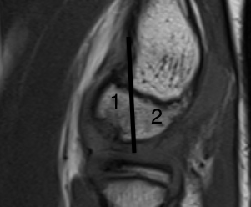

Coronal
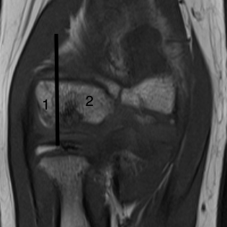

Size
Sagittal view
Length
Width
Depth
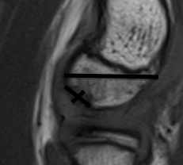

Coronal view
Length
Width
Depth
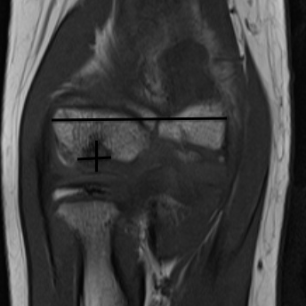

Physeal patency
Open
Closing
Closed

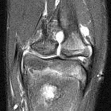

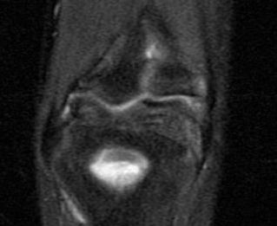

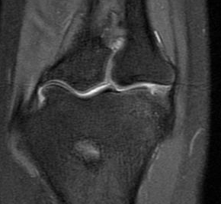

Joint effusion
Yes
No
Amount? Saddle bag idea
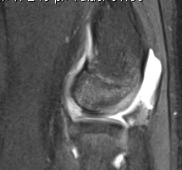

Cartilage
Thinned
Normal
Thickened
Breached

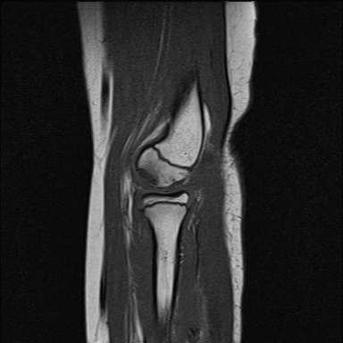

Most of the slides I found do not do a great job with regards to the evaluating the thickness. This therefore may be something that should not be included.

Interface
Border
Defined
Ill-defined

Fluid in interface between parent and progeny
To qualitatively distinguish between the hyper-intense signal in the “parent” bone and the hyper-intense signal at the interface between progeny and parent bone, the “crème”(like slide below).
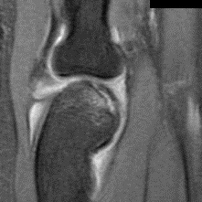

Progeny
Present
Fragmented
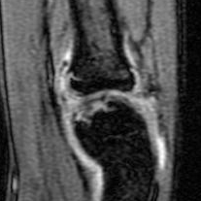
Loose ?
Absent

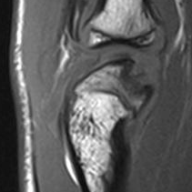

Parent bone
Cysts
Diffuse edema
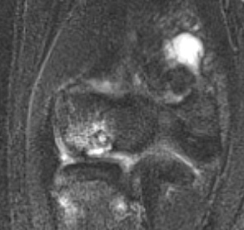

Cysts may be a good part of the classification though I am not sure that the condylar edema will be easily defined or evaluated.

