SECTION A: GENERAL INFORMATION

A1. | Patient ID: | __ __ - __ __ __ - __ |  |  |  |  | Patient Name:
A2. | Study visit: | ₀ Baseline |  | ₁ Surgery | ₂ 6 Weeks | ₃ 3 Months |  |  | [Patient label may be put here]
 |  | ₄ 6 Months |  | ₅ 1 Year | ₆ 2 Years | ₇ Interim
A3. | Date of x-ray: |  | __ __ / __ __ / __ __ __ __
 |  |  | Month Day Year
A4. | Surgeon ID: |  | __ __ __

SECTION B: X-RAY CLASSIFICATION (Baseline ONLY)

B1. | Is this the patient’s baseline x-ray (i.e. pre-surgery)? |  |  |  | ₁ Yes | ₀ No (If No, continue to SECTION C, on back)
B2. | Location of the OCD lesion (please select one):
 |  | ₁ Medial femoral condyle
 |  | ₂ Lateral femoral condyle
 |  | ₃ Patella
 |  | ₄ Trochlea
 |  | ₅ Tibia
B3. | Size:
 |  | 1. Standing AP | Width of OCD lesion |  | __ __ mm
 |  |  | Width of knee |  | __ __ mm
 |  |  | Maximum depth of lesion |  | __ __ mm
 |  | 2. Notch | Width of OCD lesion |  | __ __ mm
 |  |  | Width of knee |  | __ __ mm
 |  |  | Maximum depth of lesion |  | __ __ mm
 |  | 3. Lateral | Width of OCD lesion |  | __ __ mm
 |  |  | Width of knee |  | __ __ mm
 |  |  | Maximum depth of lesion |  | __ __ mm
B4. | Characteristics of Parent Bone:
 |  | In comparison to the unaffected parent bone, the radiodensity of the rim of the parent bone is predominantly:
 |  |  | ₁ More
 |  |  | ₂ Less
 |  |  | ₃ The same
B5. | Characteristics of the Progeny Bone:
 |  | 1. Visualization | Is the progeny bone visualized? |  |  |  | ₁ Yes |  | ₀ No
 |  | 2. Fragmentation | Is the progeny bone fragmented? |  |  |  | ₁ Yes |  | ₀ No
 |  | 3. Displacement | Is the progeny bone displaced? |  |  |  | ₁ Yes |  | ₀ No
 |  | 4. Radiodensity | In comparison to the parent bone, the radio-density of the CENTER of the progeny is: |  |  |  | ₁ More |  | ₂ Less | ₃ The same
 |  |  | In comparison to the parent bone, the radiodensity of the RIM of the progeny is: |  |  |  | ₁ More |  | ₂ Less | ₃ The same
 |  | 5. Boundary | The boundary between the parent bone and progeny is: |  |  |  | ₁ Distinct |  | ₂ Indistinct
 |  | 6. Shape | The shape of the articular side of the progeny bone is: |  |  |  | ₁ Convex |  | ₂ Concave | ₃ Linear
SECTION C: X-RAY CLASSIFICATION (Baseline and Follow-up)
C1. | Healing:
 |  | 1. Radiodensity |  | In comparison to previous radiographs (if available), the radiodensity of the progeny is:
 |  |  |  | ₁ More
 |  |  |  | ₂ Less
 |  |  |  | ₃ The same
 |  | Mark on the continuum below, denoting the current stage of healing with respect to radiolucency:
 | Totally radiolucent |  |  |  |  | Same radiodensity as parent bone
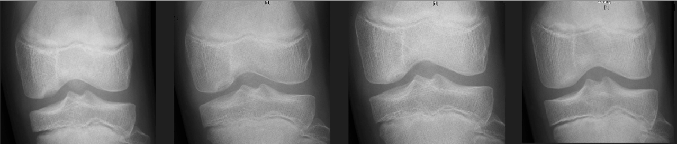
 |  | 2. Boundary | In comparison to previous radiographs (if available), the boundary is:
 |  |  | ₁ More
 |  |  | ₂ Less
 |  |  | ₃ The same
 |  | Mark on the continuum below, denoting the current stage of healing with respect to boundary:
 | Totally distinct |  |  |  |  |  |  | Totally indistinct
